Practical Unfolding for Geostatistical Modeling of Vein-Type and Complex Tabular Mineral Deposits
C.V. Deutsch
University of Alberta

ABSTRACT: Geostatistical modeling works best in Cartesian coordinates. The basic approach is to take large-scale curvilinear structure, flatten it, model the variability, and put the values back in original coordinates. A practical one-to-one reversible transformation is proposed with a straightforward set of functions to permit simple implementation. The approach allows for (1) improved variogram modeling: the directions for variogram calculation follow geological continuity, (2) improved characterization of the limits to geologic mineralization: the hangingwall and footwall can be modeled more realistically, (3) improved uncertainty characterization: it is easier to simulate uncertainty in the thickness, rock types, and grades in the unfolded coordinate space than it is to assess uncertainty in a sold/wireframe, and (4) improved trend modeling: it is possible to compute simplified trend models perpendicular to structure, along strike, and down dip.

Inroduction
Geological modeling of vein type deposits is important. There are three computer-aided approaches to modeling these deposits:

- A conventional block modeling approach may be used when the structure of the vein is very complex and there are many veinlets. There is no attempt to explicitly model the structure of the vein; it is deemed to complex.
- A 2-D modeling approach may be used when the vein is fairly flat after a rotation of the original Cartesian coordinates {X,Y,Z} to along strike, down dip, and perpendicular to the structure coordinates {X_{R},Y_{R},Z_{R}}. The hangingwall, footwall, thickness, rock types, and grades are all modeled in the rotated coordinate system. The modeling may be 3-D in the corrected coordinates. The rotation can be reversed at any time.
- A wireframe or geological solid may be defined to model the envelope of the mineralized vein. There are various ways to assemble the 3-D mineralized volume. There are various ways to represent/store the resulting model in the computer.

The methodology developed in this paper is aimed primarily at the third approach. The methodology for conventional block modeling and 2-D modeling is well understood. The goal here is to simplify a reasonably complicated vein structure and permit improved heterogeneity modeling and uncertainty characterization. The two main problems with geological solid modeling are that (1) the solid (mineralized envelope) is very deterministic and it is difficult to perform uncertainty assessment, and (2) the coordinates within the solid do not conform to the boundaries of the mineralization. The proposed unfolding algorithm will facilitate uncertainty assessment and grade modeling using local vein coordinates.

Unfolding is not a new concept. A number of software packages perform some type of unfolding. The CCG research group is committed to providing source code to industry sponsors and to developing new algorithms for geomodeling. The unfolding algorithm presented here is a natural extension of well understood geometric modeling principles.

ORTHOGONAL ROTATION
It is often convenient to rotate the original coordinates (UTM or local) so that they are approximately along strike, down dip, and perpendicular to the vein. This is most simply performed by two 2-D rotations. The logic of all GSLIB coordinate systems is that the original X direction is in the East direction, the original Y direction is North, and the original Z direction is elevation – vertically upward. The goal is to translate data and locations in this original coordinate system {X,Y,Z} to be along strike, down dip, and perpendicular to the structure coordinates {X_{R},Y_{R},Z_{R}}. Let’s do this in two steps.

Consider a translation to (x_{o}, y_{o}) and clockwise rotation by angle α to orient the X axis along the strike direction and the Y direction in the dip direction. The Z direction remains unchanged while the X and Y axis are rotated in a clockwise angle α. Note that the clockwise angle is looking down along the Z axis toward the origin. The equations for this rotation:
(1)
The rotated X_{R} coordinate is the final coordinate. The Y_{I} coordinate is intermediate. The next step is to rotate Y_{I} and Z around the X_{R} axis to orient the Y direction down dip and the Z direction perpendicular to the structure. Consider a translation of the Z coordinate to the top of the deposit (z_{1,o}) and a clockwise rotation by angle β (looking along the X_{R} axis toward the origin).
(2)
These two rotations can be put together into a single matrix multiplication. Note that this is not exactly the same as described in Geostatistical Reservoir Modeling. The approach there was to orient the X axis down dip. Here, X is along strike, Y is down dip, and Z is perpendicular to structure.
(3)
The modeling may be 3-D in the corrected coordinates. The rotation can be reversed at any time. It could be done by inverting this matrix or by reversing the transformations. Reversing the transformations leads to the following.
(4)
The matrix equations (3) and (4) are useful to convert UTM or mine coordinates to a vein-specific coordinate system that is aligned along strike, down dip, and perpendicular to structure. Geostatistical models can be constructed in the rotated coordinate system {X_{R},Y_{R},Z_{R}} and all values can be rotated back to original coordinates {X,Y,Z}.

UNFOLDING
The orthogonal rotation and translation described above should be performed before applying the unfolding algorithm if the deviations are large. This may be convenient. The unfolding algorithm creates a new along-strike coordinate (X_{U}) and a new perpendicular-to-structure coordinate (Z_{U}). The down dip coordinate is not changed (Y_{U}=Y_{R}). A number of different implementation decisions/alternatives are possible. Figure 1 illustrates the basic idea. Some remarks:

- The black dots are control points and would be digitized off X_{R}-Z_{R} cross sections. The control points are tied together down dip (along the orange lines), therefore, there should be the same number of control points along each cross section: n_{cp}.
- The local perpendicular to structure coordinate Z_{U} is rotated in the plane of the X_{R}-Z_{R} cross sections. The red lines on the cross section illustrate this rotation. The red lines bisect the angle created by the control points on either side of the control point under consideration. The gray dots at the end of each cross section are projected from the second-first and n_{cp}-1 to n_{cp} points.
- The local perpendicular to structure coordinate Z_{U} is not rotated in the plane of the Y_{R}-Z_{R} cross sections. Note that the red lines on the long section are perpendicular to the Y_{R} coordinate.
- The spacing of the cross sections down dip (in the Y_{R} coordinate direction) is likely to be regular, but this is not required.
The unfolding algorithm uses a grid of control points to achieve the flattening. In the schematic Figure 1 there are four control points along strike (n_{cp} =4) and there are three down dip (n_{y} =3). The location of the control points must be digitized on hardcopy sections (unlikely) or electronic sections. The control points are defined by the size of the grid (n_{cp} and n_{y})and the following set of coordinates:
(5)
Three additional parameters are needed to define the unfolding algorithm: (1) grid refinement along strike – the number of intermediate lines defining iso-X_{U} lines, see blue lines in the sketch below, (2) degree of grid refinement down dip – the number of iso-Y_{U} lines, and (3) the allowable distance from the flattened plane – the distance from the dark blue line. The first and third parameters are illustrated in Figure 2.

The down dip coordinate is unchanged: Y_{R} = Y_{U}. As illustrated in Figure 3, the along strike direction coordinate X_{U} is calculated to follow the piecewise linear center line digitized from cross sections. The perpendicular to structure coordinate Z_{U} is calculated to be approximately perpendicular to local structure. The X_{U} coordinate is equal along the red lines that bisect the angles at the control points. A delta X_{U} must be specified. Z_{U} The coordinate is zero at the centerline, positive above, and negative below.

The X_{U} and Z_{U} coordinates on each cross section within each pair of control points is easy to visualize, see the little sketch below. The region between two control points depends on the control points on either side; the orientation of the Z_{U} coordinate bisects the two angles and the X_{U} coordinate is linearly scaled between the two bisectors. For this reason, there are additional control points mirrored on both sides of the X_{R} cross sections (see the gray dots on Figure 1).
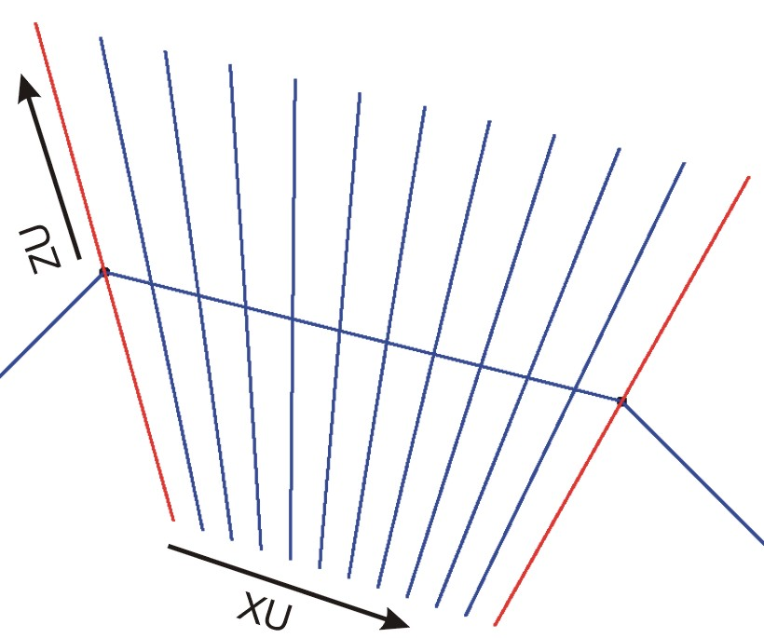

There is a 2-D grid of control points in the plane of the vein (the X_{R} and Y_{R} coordinate plane) that is relatively widely spaced. The conversion of X_{R}/Z_{R} coordinates to X_{U}/Z_{U} coordinates within each segment (see sketch above) may be quite sensitive to the relatively wide spacing along X_{U} and along Y_{U}. The interpolation of the X_{U} coordinate is linear; there are 10 lines shown in the sketch above at a spacing of 1/11 of the spacing between the X spacing of the control points. Refinement in the YR coordinate is more important to avoid artifacts.

The Y_{R} control sections are refined to minimize abrupt discontinuities. Figure 4 illustrates Nyref intermediate sections between two pairs of control points. The alternating colors indicate the region of influence of each section. The Xs mark intermediate control points. These values are interpolated linearly between each pair of control points, that is, along the orange lines connecting the black dots. For example, the using the notation of Equation 5, the Z_{R} coordinate of a particular k intermediate (refined) cross section:
(6)
The refined sections along the Y_{R/U} coordinate are considered just like the control sections, that is, the X_{U} and Z_{U} coordinates are constructed like in the sketch above.

The rotated coordinate system {X_{R},Y_{R},Z_{R}} is unfolded to {X_{U},Y_{U},Z_{U}}. The continuity of the geometric structure, rock types, and grades is assumed to be better behaved in the unfolded coordinate system: {X_{U},Y_{U},Z_{U}}. Clearly, there is a distortion of the coordinates where the X_{U} coordinate is compressed in some places and expanded in others. Grid blocks in {X_{U},Y_{U},Z_{U}} do not have the same volume/mass. Three considerations result from this:

- The original data should be composited to a constant length in original coordinates {X,Y,Z}or rotated coordinates {X_{R},Y_{R},Z_{R}}. This may pose problem at contacts where assays are started again. A short compositing length can be used to mitigate this problem.
- The kriging/simulation of rock types and grades in {X_{U},Y_{U},Z_{U}} coordinate space should be performed at a relatively fine resolution relative to the volumes of interest. This makes it reasonable to assign point values in the transformed coordinate space.
- Tonnages and average grades within grid blocks/stopes should be calculated in the rotated {X_{R},Y_{R},Z_{R}} or original {X,Y,Z} coordinate systems to avoid any bias.

Clearly, the vein cannot be simultaneously wide/thick and highly tortuous. It is easy to imagine that the bisectors at the control points could cross causing ambiguity in the coordinate. Figure 5 illustrates the problem. An ad hoc correction is applied in the program.

Another issue is that bifurcations and multiple veins are not explicitly handled by the modeling procedure. They may connect in a geologically realistic manner in the unfolded coordinate system, but multiple veins will likely need to be modeled separately. Bifurcations and internal variations in the rock types may require modeling a categorical variable prior to modeling grades. Sequential indicator simulation and/or truncated Gaussian simulation are candidate techniques. Surfaces (see Figure 6), rock types, and grades will all be modeled in unfolded space and the results back transformed to original coordinates.

Small Example
The first step is to choose the original coordinates to unfold (x_{R},y_{R},z_{R}). An overall rotation and translation could be considered. This can be reversed at any time. The x_{R} coordinate should be approximately along strike, the y_{R} coordinate should be approximately down dip, and the z_{R} coordinate should be approximately perpendicular to the structure. The number of Y_{R} slices for control points is chosen (n_{ys}). There is no need to choose these slices too close together. The spacing will depend on the scale of variability that you feel important to capture. The number of control points along each Y_{R} slice is chosen (n_{cp}). Then, the X_{R},Z_{R} location of the n_{ys} • n_{cp} control points must be digitized.

Three drillholes on a cross section and an unfolding scheme defined by five control points are shown on Figure 7. The maximum perpendicular distance from the center line was set to 50.0, the distance between control points was set to 100.0 and 9 intermediate lines were specified between the control points. The data within the maximum perpendicular distance are shown in unfolded coordinates in Figure 8. In practice, only the data within the mineralized vein would be transformed (not all of the data within some maximum distance). The unfolded data were back transformed to original locations; see Figure 9. There are some minor differences – about 0.2m on average. An iterative scheme could be considered to improve the results. Figure 10 shows five models for the hangingwall and footwall geometry. These surfaces could be used to clip the grade modeling. The clipping could be done in unfolded or original coordinates. These surfaces were constructed independently, but it would be more common to simulate the footwall location and then simulate the mineralized thickness. The simulated realizations of the footwall and thickness would be used in pairs to clip the kriged or simulated mineralization models. Figure 10 also shows a realization of grades in unfolded and original coordinates. These grades have not been clipped by footwall and thickness grids.

Conclusions
There are many area of future work. Most importantly, the algorithm needs to be tested and used on a number of examples where the glitches can be worked out. Splines could be used instead of linear segments for the center lines.

The goal of this work is to provide a geometric framework for the geostatistical modeling of vein type deposits that is amenable to transfer uncertainty in structure, rock types and grades through to the optimization of stope boundaries. Working within a fixed wireframe or solid model is unacceptable; the limits of the mineralization must be modeled stochastically. Unfolding the coordinates prior to surface, rock type and grade modeling greatly simplifies the application of geostatistical modeling techniques.

Unfolding is not new. Many commercial software applications have the capability. Those applications were not reviewed for this implementation. This is a fresh implementation with no legacy issues. Of course, the accumulated learning of previous applications and other good ideas are not accounted for. The approach will likely be refined with application. The concept of open and transparent source code is important; anyone can extend the basic ideas seeded here.

ACKNOWLEDGEMENTS

The industry sponsors of the Centre for Computational Geostatistics (CCG) are thanked for their support of this work. The Canadian funding agency NSERC is also thanked for financial support.

REFERENCES

- Deutsch, C.V., and Journel, A.G., GSLIB: Geostatistical Software Library and User’s Guide, Second Edition, Oxford University Press, New York, NY, 1998.
- Guillier B. and Gratier JP. - Compatibility constraints on folded and faulted strata and calculation of total displacement using computational restauration (UNFOLD program). Journal of Structural Geology, 15, 3-5, p. 392-402., 1993
- Houlding, S.W., 3D Geoscience Modeling: Computer Techniques for Geological Characterization, Springer-Verlag, New York, 1994.
- Journel, A.G., and Huijbregts, Ch., Mining Geostatistics, Academic Press, New York, 1978.
- Mallet, J.L, Geomodeling, Oxford University Press, New York, NY, 2002.
- Press, W.H., Teukolsky, S.A., Vetterling, W.T., and Flannery B.P., Numerical Recipes in Fortran 90: The Art of Parallel Scientific Computing, Volume 2 of Fortran Numerical Recipes, Cambridge University Press, New York, 2002.

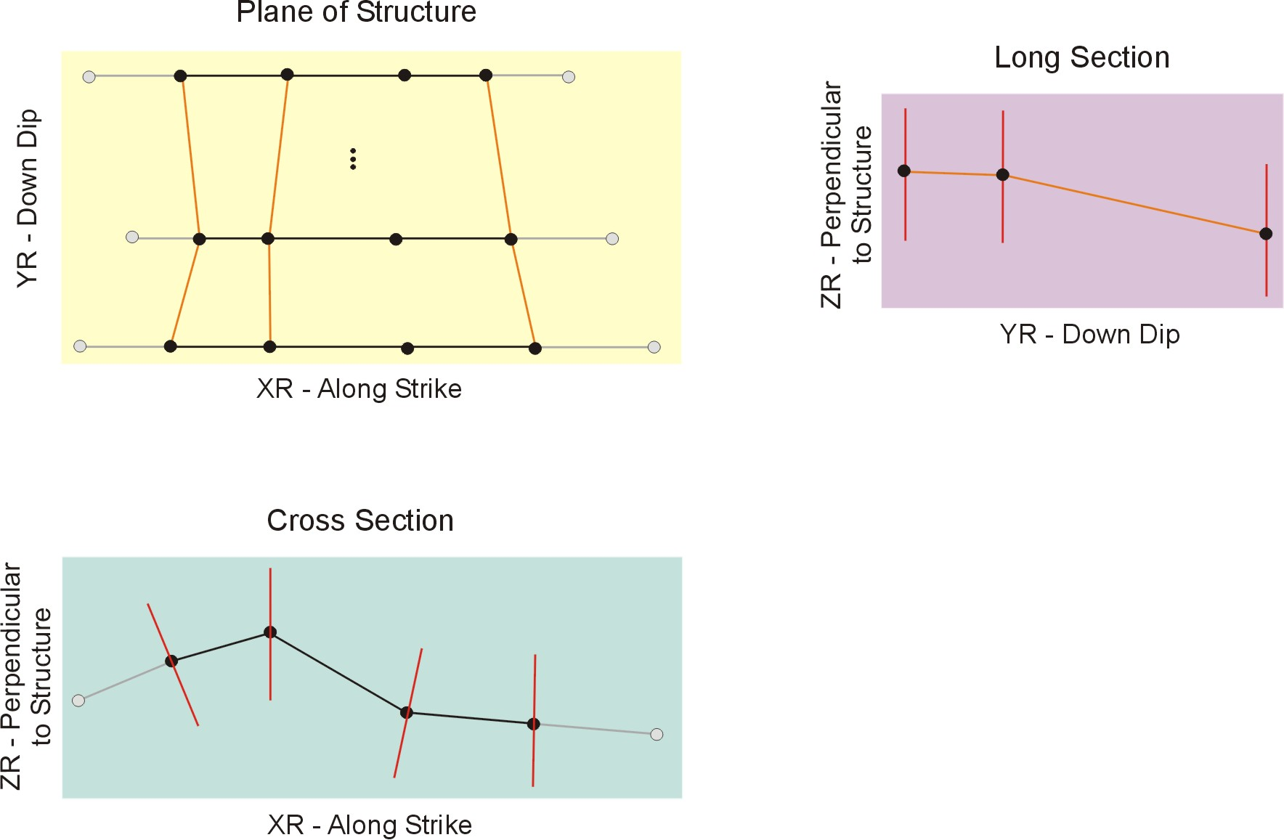

Figure 1: Basic structure of unfolding algorithm. There are three views: plane of vein – upper left, cross section – lower left, and long section – upper right.
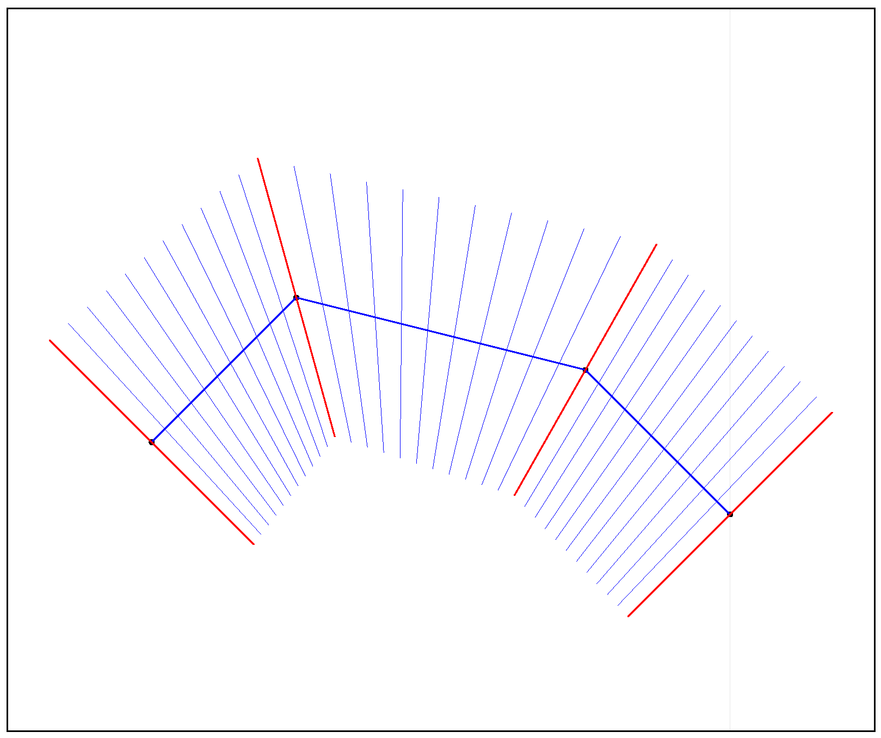

Figure 2: Schematic illustration of the grid refinement along strike (the intermediate blue lines between the control point angle bisectors) and the maximum distance from the flattened plane (the distance perpendicular to the solid central blue line.

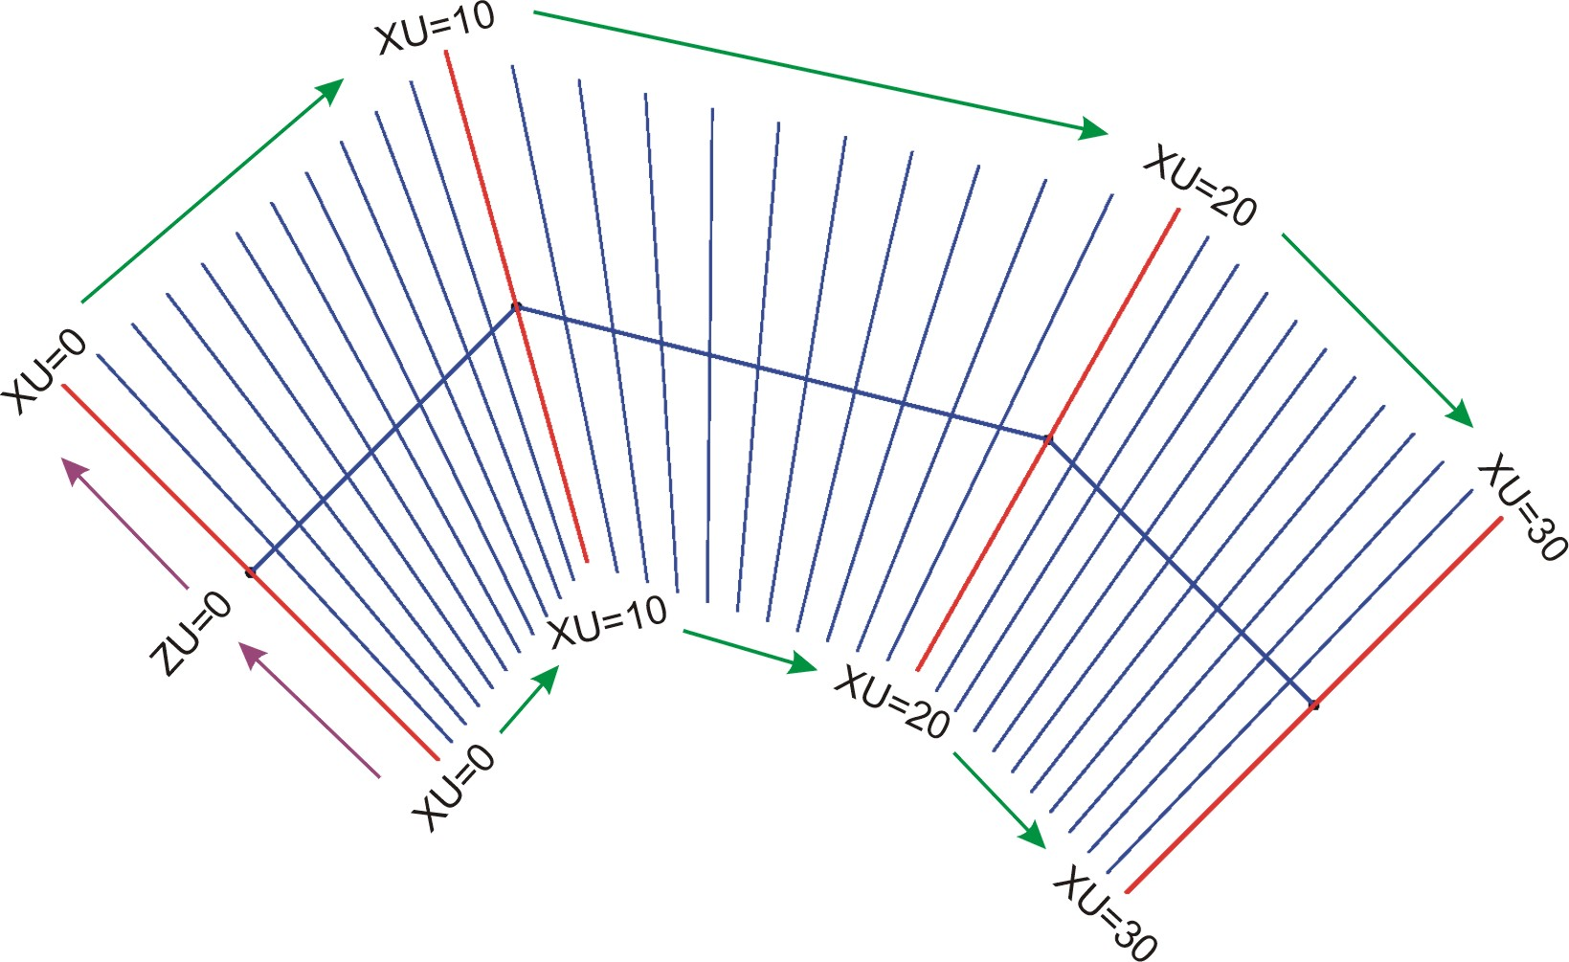

Figure 3: Schematic illustration of the unfolded X_{U} and Z_{U} coordinates. The X_{U} interval between the control points is fixed at 10 in the example.

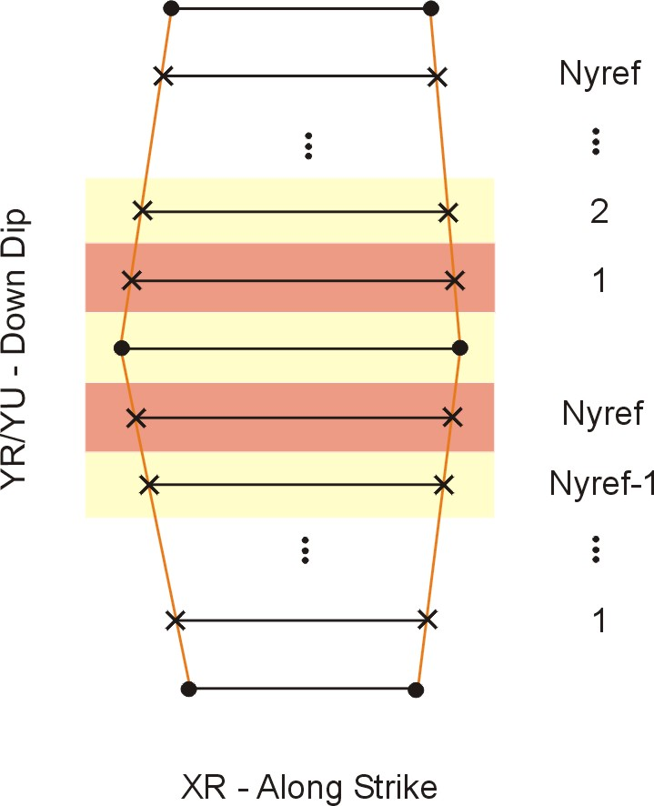

Figure 4: Schematic illustration of how multiple Y_{U} sliced are considered between every set of control points. This refinement is performed automatically.

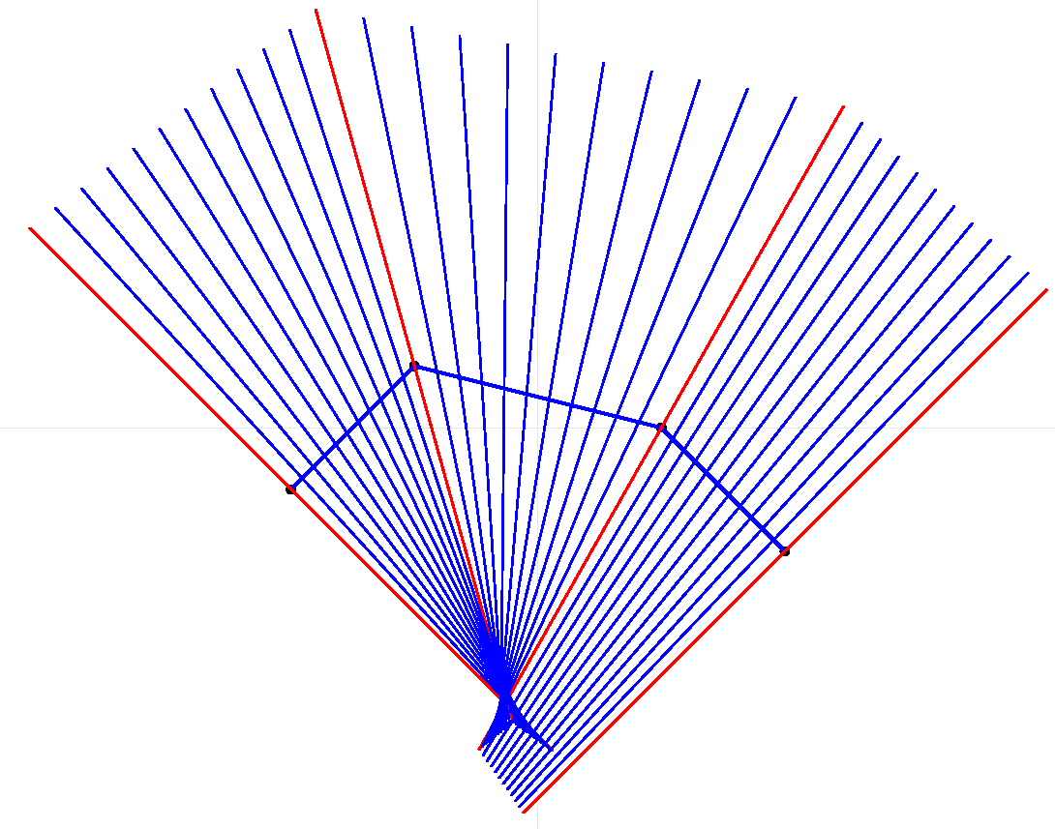

Figure 5: Problem with ambiguous coordinate calculation when the curvature and distance from centerline are simultaneously large.

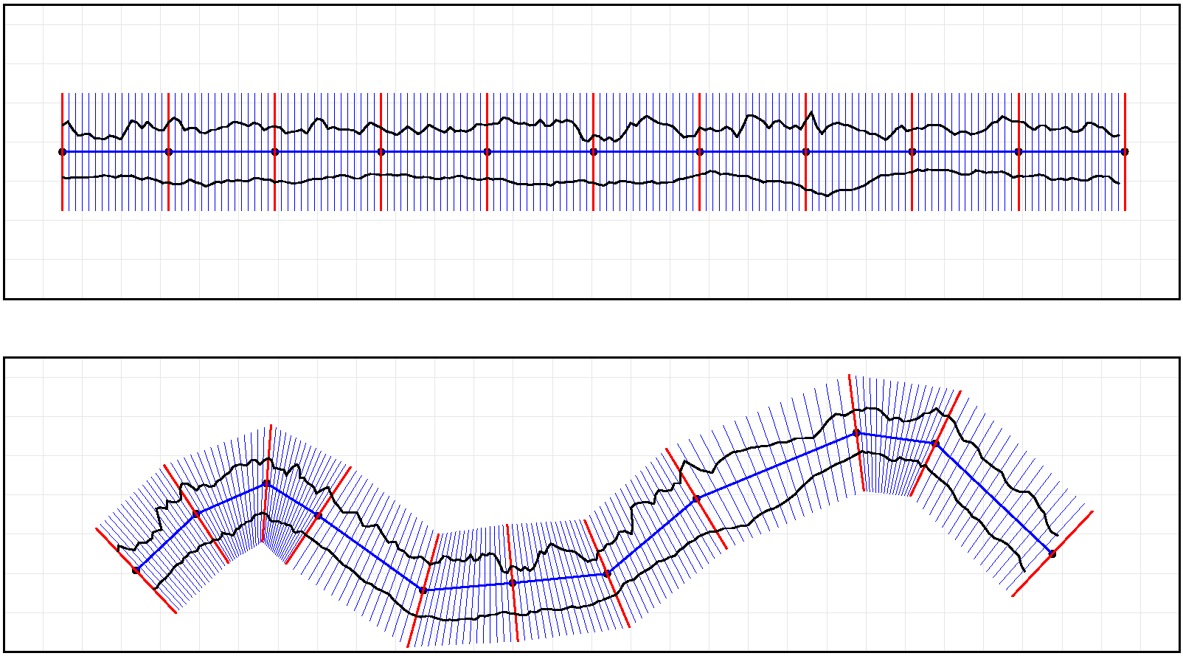

Figure 6: Example surfaces in unfolded coordinates (top) and in original rotated coordinates (bottom).

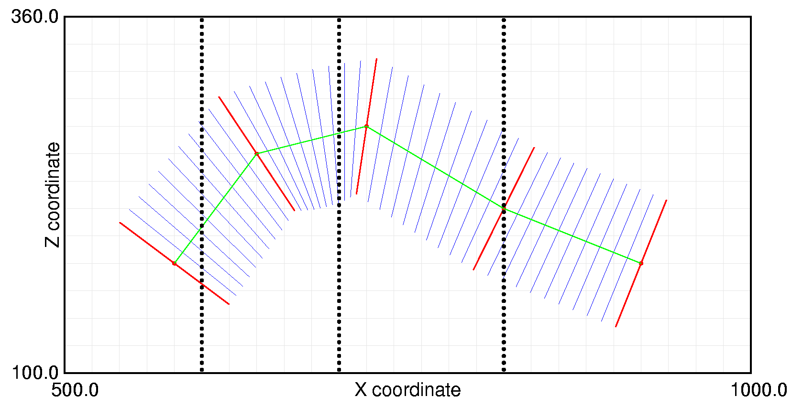

Figure 7: Example data for illustrating the unfolding programs. The black dots represent composite centroid locations, the red lines are at the control points, the blue lines are between the control points, and the green line connects the control points at a Z_{U} coordinate of 0.0.
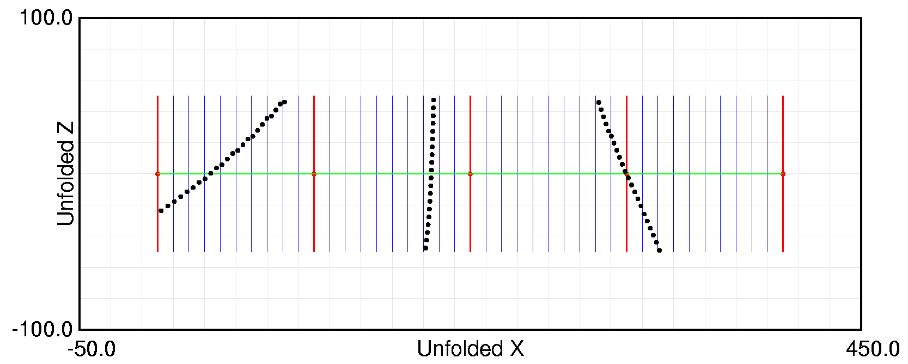

Figure 8: Example data (same as Figure 7) in unfolded coordinates. Note how data outside of the transformed space is omitted. There are some minor distortions at the top of the drillhole on the left.
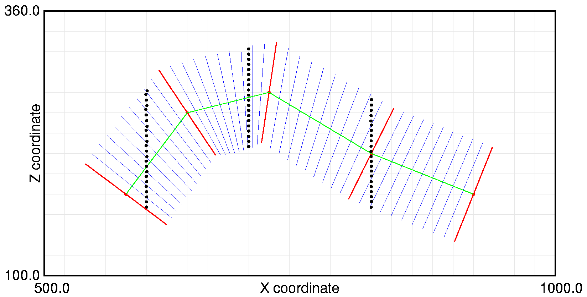

Figure 9: Data from Figure 8 back transformed to original coordinates. These points should be compared with those in Figure 7. There are some minor distortions.
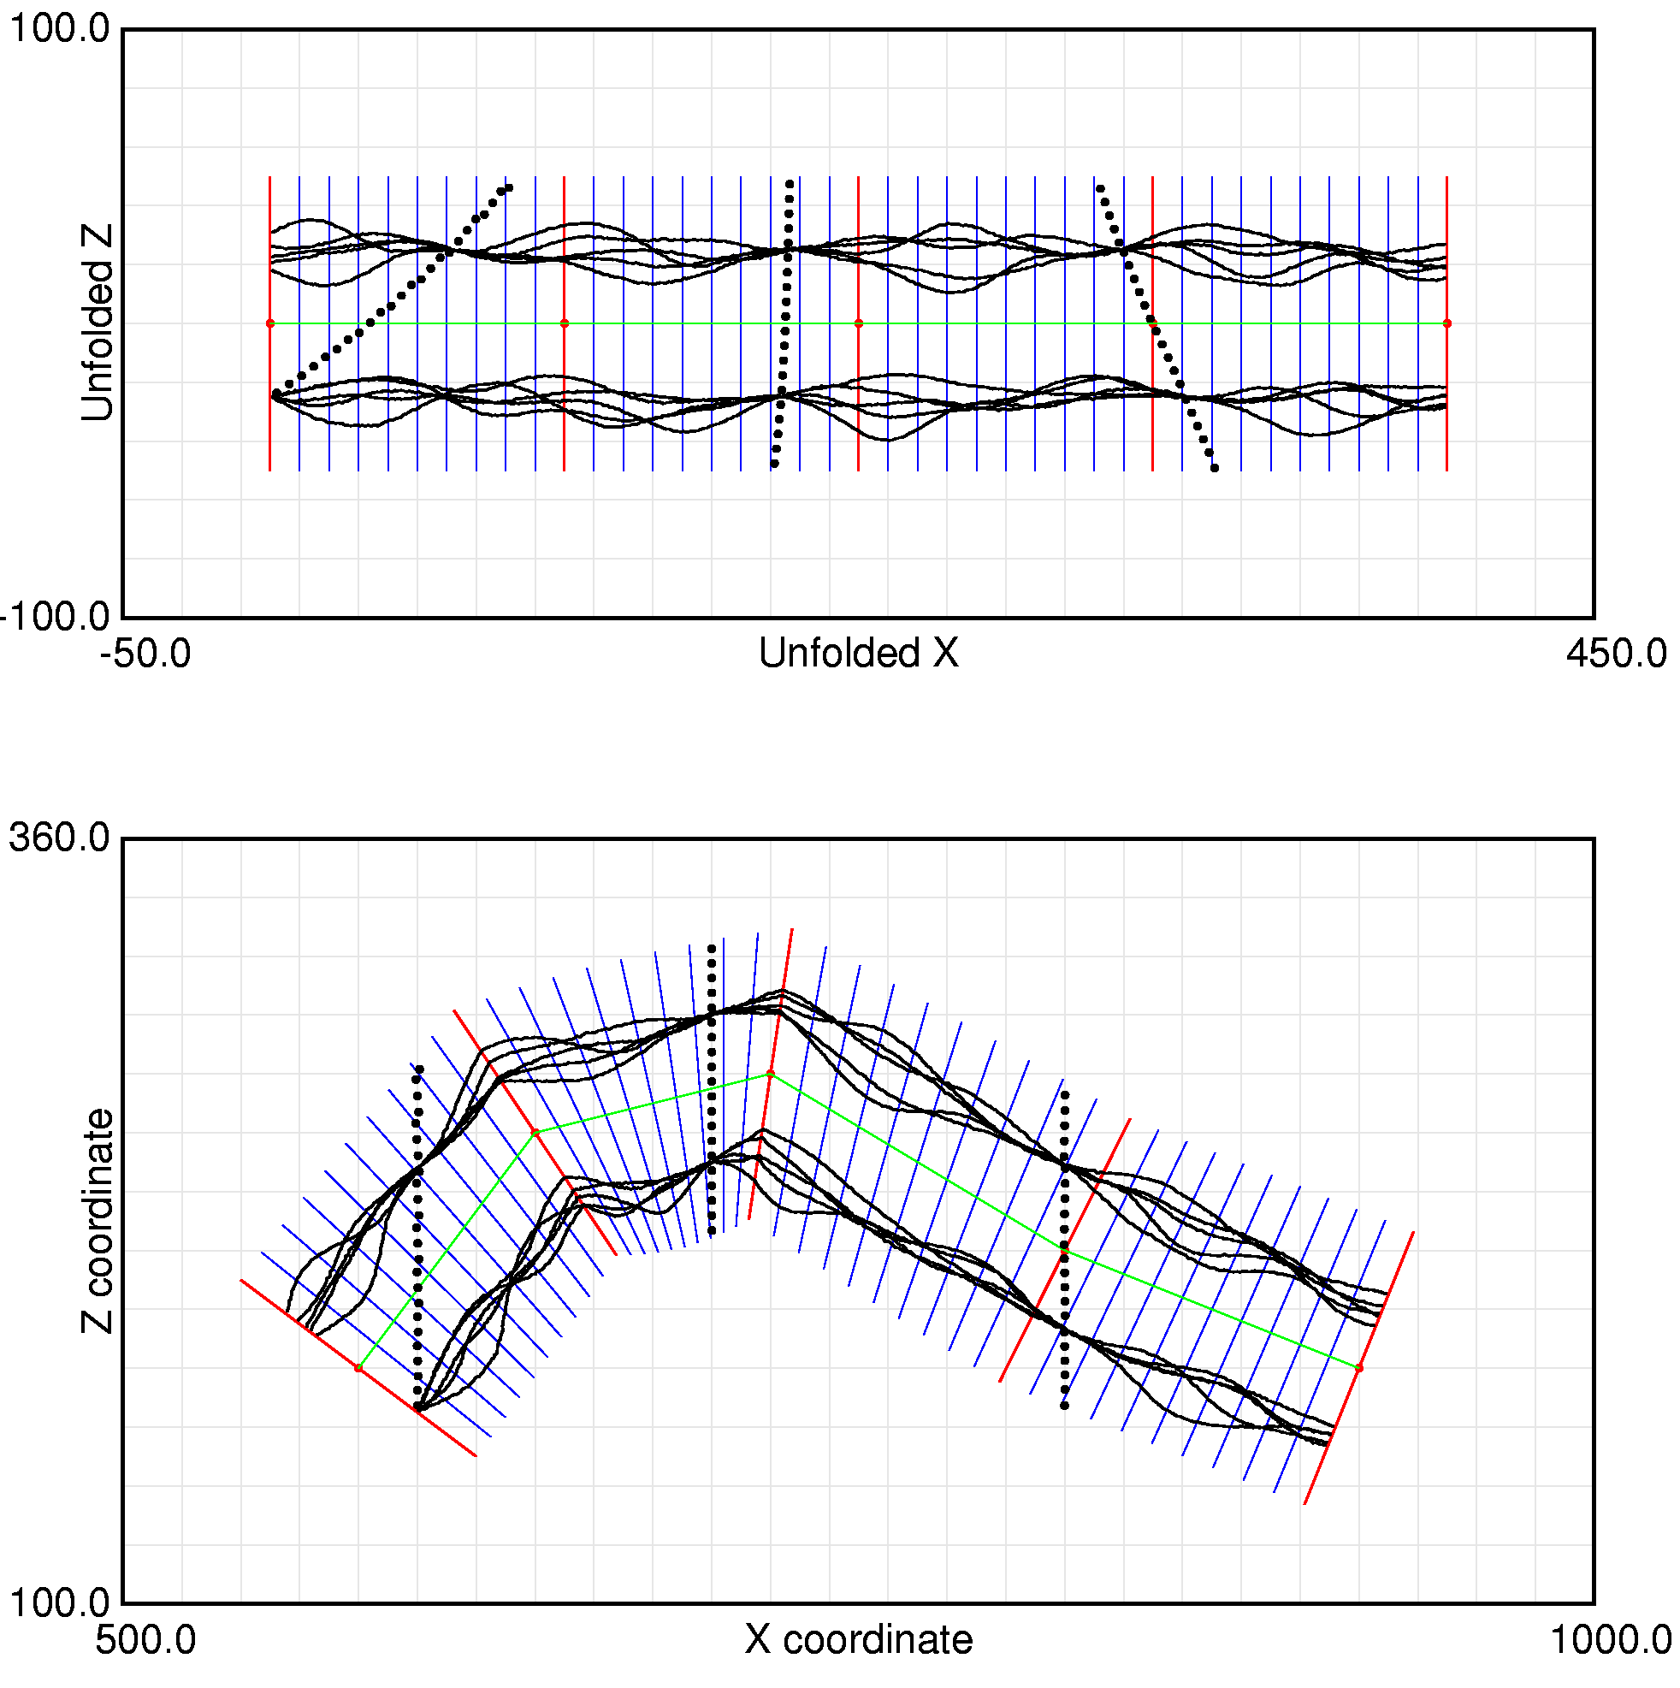
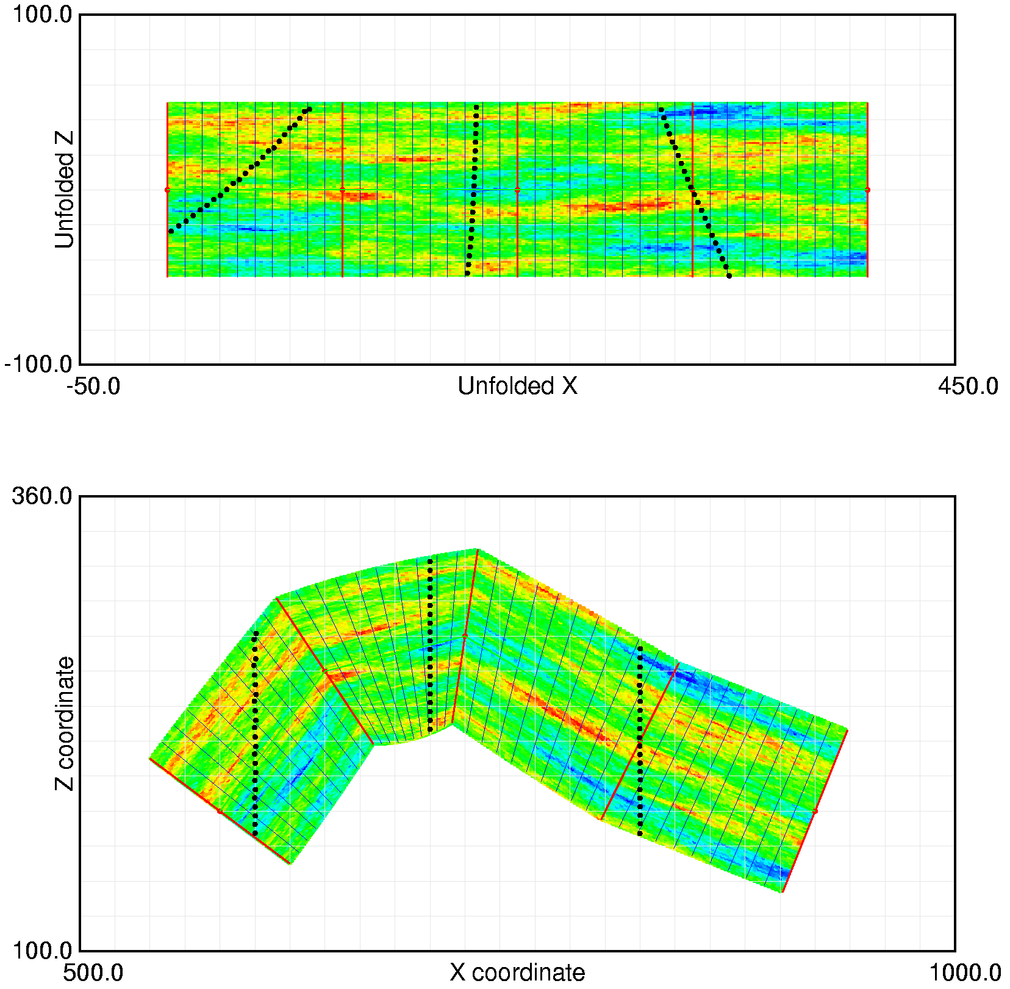

Figure 10: Five top and base surfaces that are constrained at the drillhole locations. These surfaces could be used to clip the grade modeling. A grade realization in unfolded and original coordinates is shown on the right.

